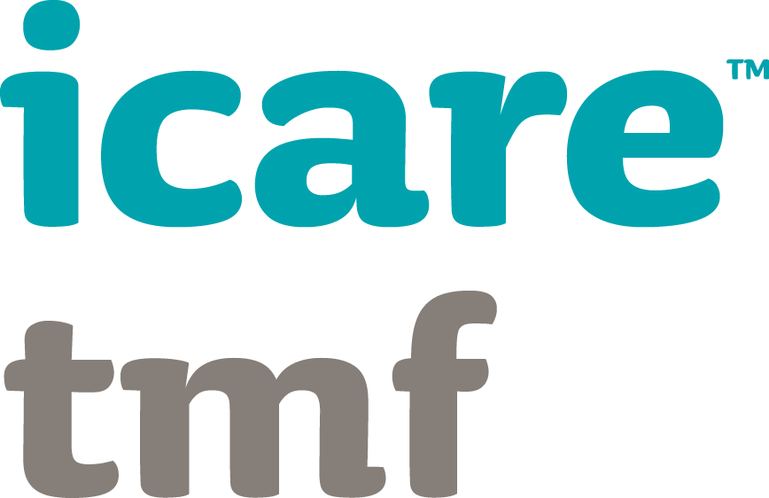

Frameworks and Systems application

important information
This application form is due by 6:00pm Friday 26 May 2017.
To submit your application please email it along with your supporting documents to: riskservices@suncorp.com.au
A submission summary is required to promote your submission in the App.
This Award recognises excellence in the implementation of a risk management related framework or system.
Awards are decided at the judges’ discretion and may be awarded for each stream (i.e. work health & safety, injury management, risk management or organisation resilience) or as a whole;large, mid or small agencies will be awarded based on merit.
Organisations that have progressed in the implementation of a framework or system and have experienced improvements in work health and safety, injury management, risk, governance, audit or organisation resilience outcomes are encouraged to apply. Successful applicants must be able to demonstrate measurable improvements in processes or performance.

Judging Criteria
Your application must clearly state how each criterion is met and be accompanied by supporting documentation.
Approach  20% | Implementation  20% | Integration  20% | Measurement  20% | Performance  20%
Nominations for FRAMEWORKS AND SYSTEMS Award
Scope of framework/system  Description of project planning  Project assessment and evaluation methodology | Executive buy-in  Implementation planning and execution  Understanding the impact on stakeholders  Consultation framework | Integration with other business systems, planning and/or activities | Performance evaluation  E.g. against KPIs, guidelines or benchmarks | Applicants MUST be able to demonstrate how their system or framework has improved organisational performance, through meeting or exceeding set performance criteria.

Instructions
For your submission to be considered, the case study and submission summary must be completed in full.
Information to support your Award submission (e.g. organisation chart, reports, statistics, promotional material, references) may be submitted separately via email to riskservices@suncorp.com.au no later than 6:00pm Friday, 26 May 2017.

applicant details
Candidate’s name: | Click here to enter text.
TMF Agency: | Click here to enter text.
Position title/team business unit: | Click here to enter text.
Email address: | Click here to enter text.
Contact number: | Click here to enter text.

If more than one organisation has been involved in the project, please complete the following:
Partnering organisation: | Click here to enter text.
Relationship to lead: | Click here to enter text.
Partner contact person: | Click here to enter text.
Partner position title: | Click here to enter text.
Partner email address: | Click here to enter text.
Partner contact number: | Click here to enter text.
Brief description of the role played in the project: (100 word max)
Click here to enter text.

Executive sign off (due 9 June 2017)
Signature of CEO (or approved delegate):
Date signed: | Click here to enter text.
Name: | Click here to enter text.
Position title: | Click here to enter text.
Email address: | Click here to enter text.
Contact number: | Click here to enter text.

☐ Yes | ☐ No
Please highlight
I agree to icare self insurance publishing details from my completed application form on its website and using the materials from my application to produce case studies and agency learning.

application form

Submission summary (200 word max)
This will be used to promote your submission in the App.
Click here to enter text.

Case Study: Title
Insert a striking quote or figure here
This should be two to three paragraphs in short sharp sentence format. Outline the issue/ incident/ findings and any significant parts of the case. Provide high level summary of events. The name of the agency or department should be in this section unless confidential material is being shared.

Overview
Introduction to the agency - describe what your agency/ department does. A few paragraphs and or dot points about who, what, when, where, and why facts.

Background
Introduction to the issue being addressed
Start this section with an introductory line, e.g. 'The following processes and measures were implemented to address XXX issue:'...
What actions were initiated to address the issue outlined under 'Background' above? i.e. Describe the approach:
- Scope of project
- Planning process
- Needs assessment and evaluation methodology
Describe any investigations, audits or inquiries made and the measurements taken.

The journey to change
What actions were initiated to address the issue outlined under 'Background' above? i.e.
Start this section with an introductory line, e.g. 'The following processes and measures were implemented to address XXX issue:'...
Describe the implementation:
- Executive buy-in
- Implementation of the project
- Impact on stakeholders
- Consultation framework
Describe the integration with:
- Other business systems
- Strategic, business and/or project planning
- Other agency programs
Describe any investigations, audits or inquiries made and the measurements taken.
Insert helpful graphs or images. Use Smart Art and colour using guide on the next page.
Try not to use too many acronyms or excessive capitalisation.
Include Client or Agency logo in the body of the text if appropriate
Results
Describe the performance
- How did the project improve organisational performance?
- Did staff engagement improve and was it measureable via survey?
Describe the performance measurement
- KPIs
- Benchmarking
- Guidelines
- How many staff undertook/will undertake the new training?
- Are there follow-up quality assessments made?

Challenges

Future strategies

This is the end of the application.

